

R and power bi project

Rafal Szymanski



May 11, 2023

Contents

1. Data source and aim 2

2. Requirements of this assignments 2

3. Importing data to R: 2

4. Viewing the data that was added to df, data frame variable 2

5. Adding (installing) tidyverse package to R Studio 3

6. Loading installed tidyverse package to R Studio for using 4

7. Checking data types in df 4

8. Checking for missing values in df 4

9. Removing missing values from df 5

10. Checking to make sure that the missing values were removed 5

11. Checking for duplicates 5

12. Rounding off Profitability and Worldwide.Gross values to 2 decimal places 6

13. Checking df variable for rows (70) and columns/variables (8) 6

14. Checking for outliers using a boxplot 6

Loading ggplot2 package to R Studio 6

Creating a boxplot that highlights the outliers 7

Checking no_outliers data set (variable) for the current row and column count 8

Removing outliers in 'Worldwide.Gross' data set 8

Checking df1 data set (variable) for the current row and column count 8

15. Summary Statistics/Univariate Analysis 9

16. Bivariate analysis 9

Scatterplot 9

Bar Chart 10

17. Exporting clean data 10

18.Power BI Dashboard 11

# Data source and aim

The data was used from:

<https://public.tableau.com/app/sample-data/HollywoodsMostProfitableStories.csv>

and the aim is to analyse the performance of Hollywood movies released between 2007 and 2012.

# Requirements of this assignments

* Create a word file and include screenshots of source code from R.
* Include 3 charts from R:
  + Box plot
  + Bar chart
  + Scatter plot

# Importing data to R:

df<- read.csv(“<https://public.tableau.com/app/sample-data/HollywoodsMostProfitableStories.csv>")

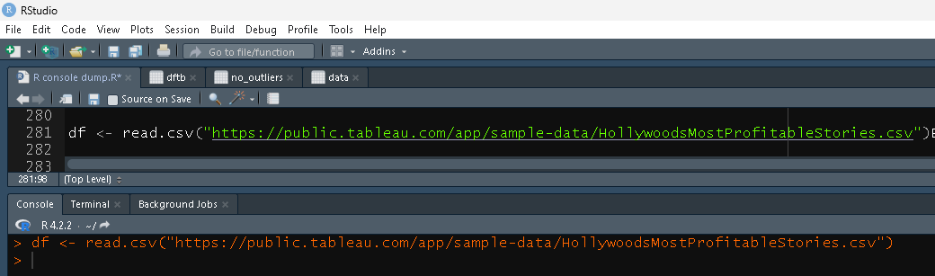

# Viewing the data that was added to df, data frame variable

View(df)

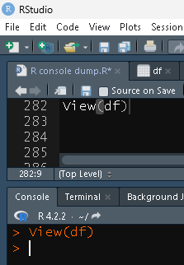

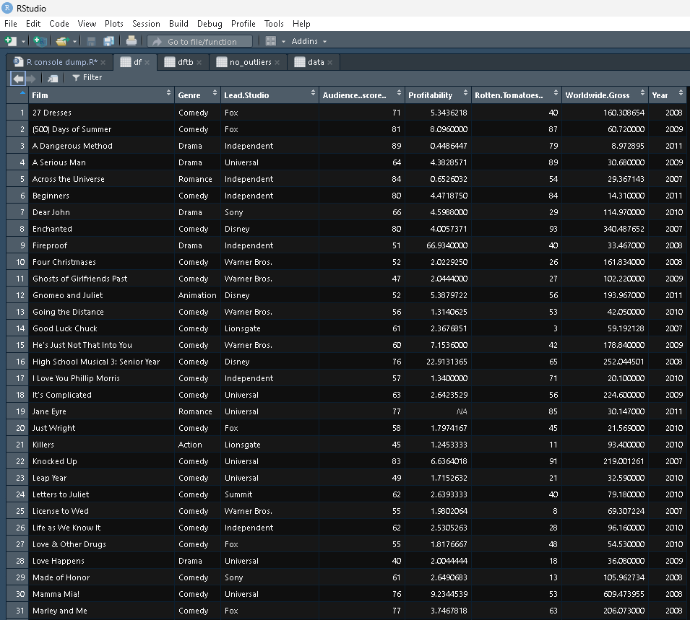And Hello

# Adding (installing) tidyverse package to R Studio

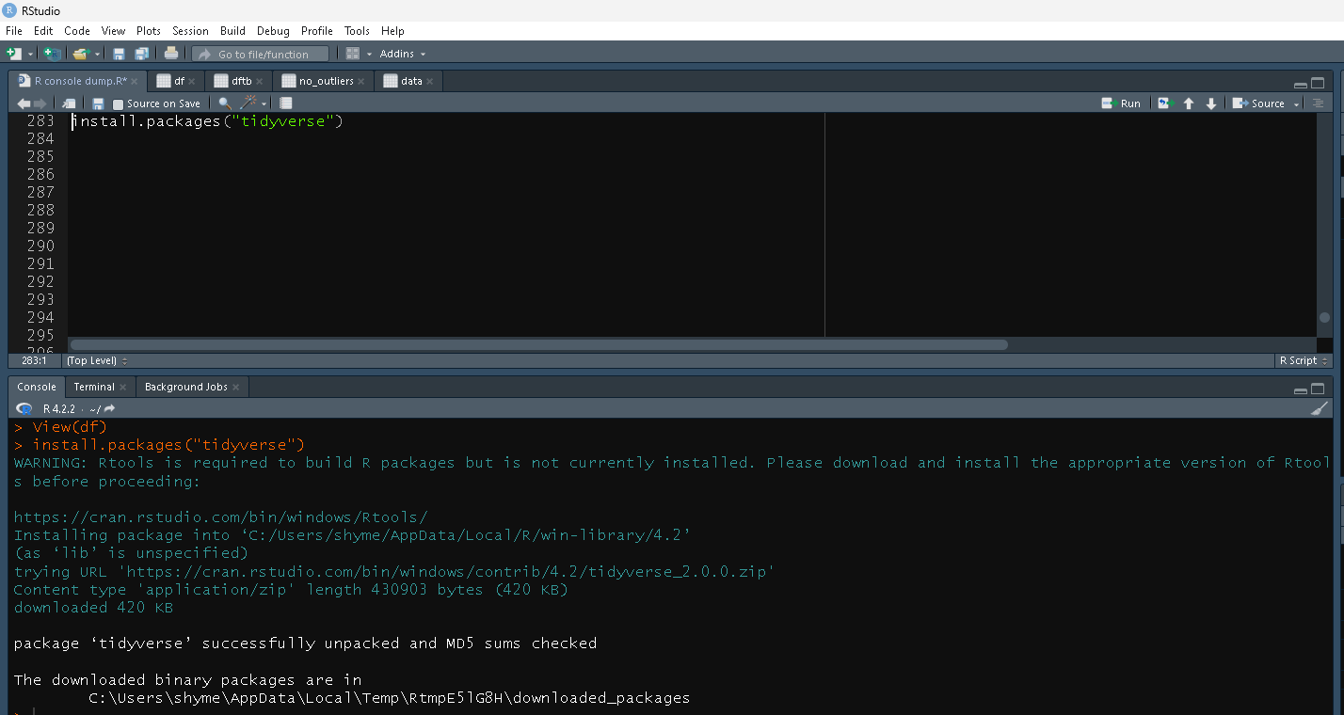install.packages("tidyverse")

# Loading installed tidyverse package to R Studio for using

library(tidyverse)

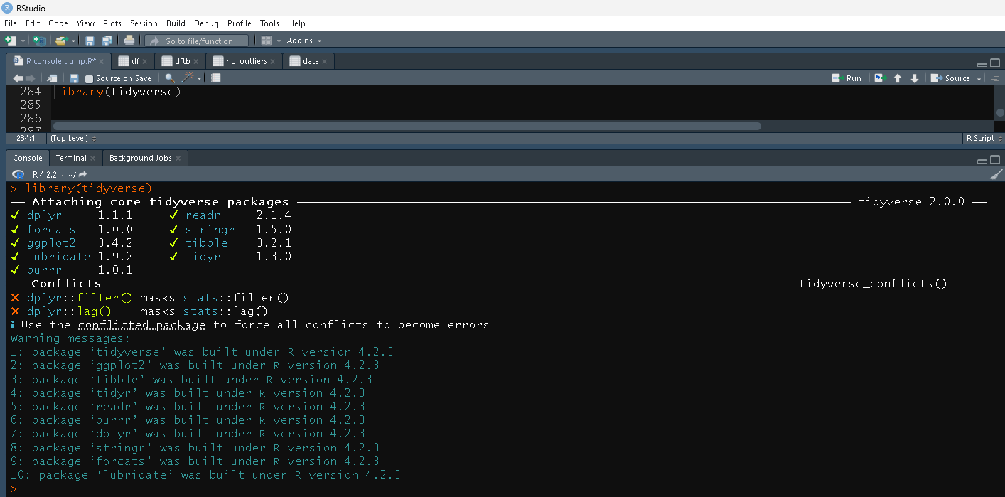

# Checking data types in df

str(df)

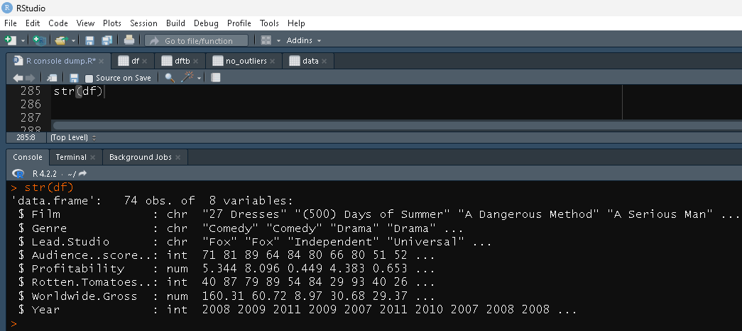

# Checking for missing values in df

colSums(is.na(df))

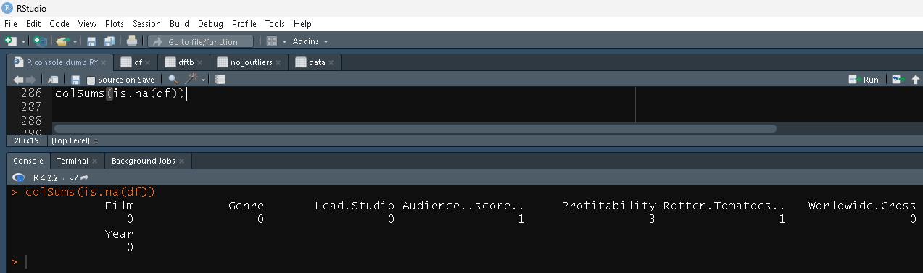

# Removing missing values from df

df <- na.omit(df)

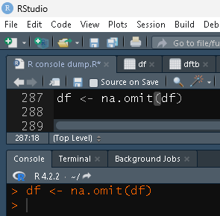

# Checking to make sure that the missing values were removed

colSums(is.na(df))

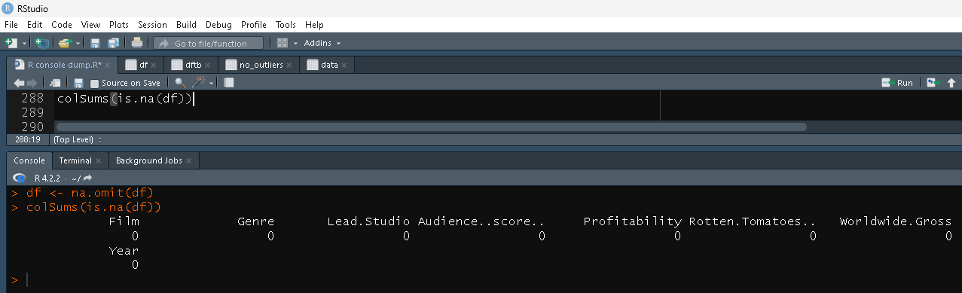

# Checking for duplicates

dim(df[duplicated(df$Film),])[1]

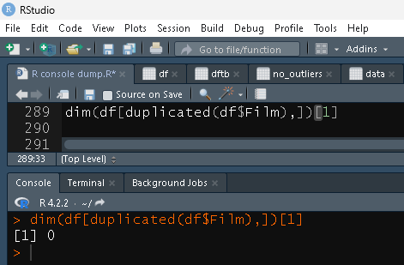

# Rounding off Profitability and Worldwide.Gross values to 2 decimal places

df$Profitability <- round(df$Profitability ,digit=2)

df$Worldwide.Gross <- round(df$Worldwide.Gross ,digit=2)

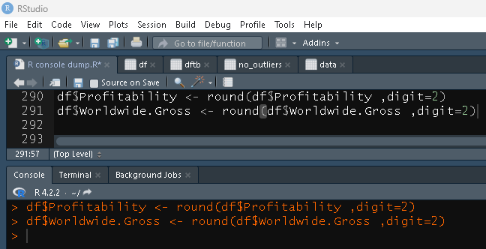

# 13. Checking df variable for rows (70) and columns/variables (8)

dim(df)

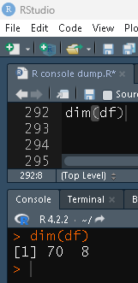

# 14. Checking for outliers using a boxplot

## Loading ggplot2 package to R Studio

library(ggplot2)

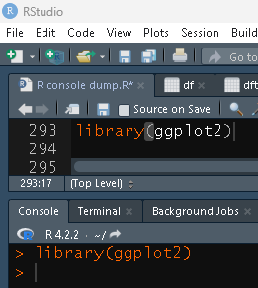

## Creating a boxplot that highlights the outliers

ggplot(df, aes(x=Profitability, y=Worldwide.Gross)) + geom_boxplot(outlier.colour = "red", outlier.shape = 1)+ scale_x_continuous(labels = scales::comma)+coord_cartesian(ylim = c(0, 1000))

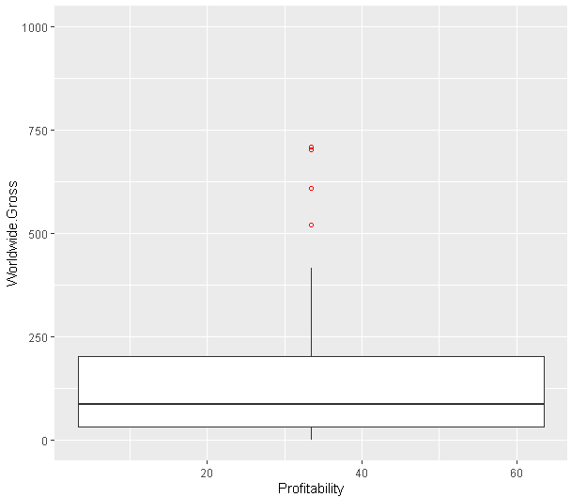  
Removing outliers in 'Profitability' data set

Q1 <- quantile(df$Profitability, .25)

Q3 <- quantile(df$Profitability, .75)

IQR <- IQR(df$Profitability)

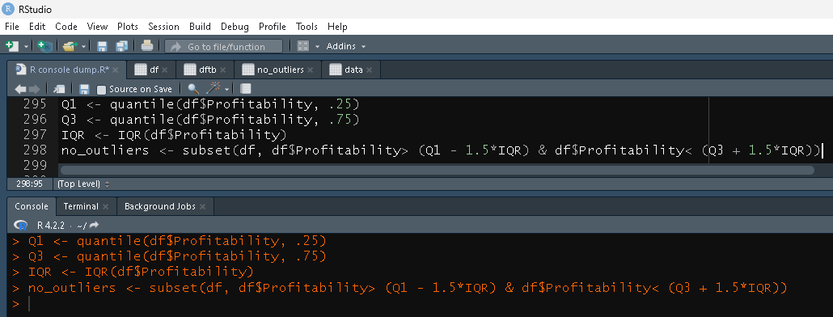no_outliers <- subset(df, df$Profitability> (Q1 - 1.5*IQR) & df$Profitability< (Q3 + 1.5*IQR))

## Checking no_outliers data set (variable) for the current row and column count

dim(no_outliers)

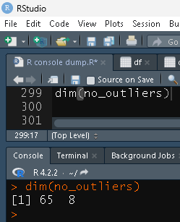

## Removing outliers in 'Worldwide.Gross' data set

Q1 <- quantile(no_outliers$Worldwide.Gross, .25)

Q3 <- quantile(no_outliers$Worldwide.Gross, .75)

IQR <- IQR(no_outliers$Worldwide.Gross)

df1 <- subset(no_outliers, no_outliers$Worldwide.Gross> (Q1 - 1.5*IQR) & no_outliers$Worldwide.Gross< (Q3 + 1.5*IQR))

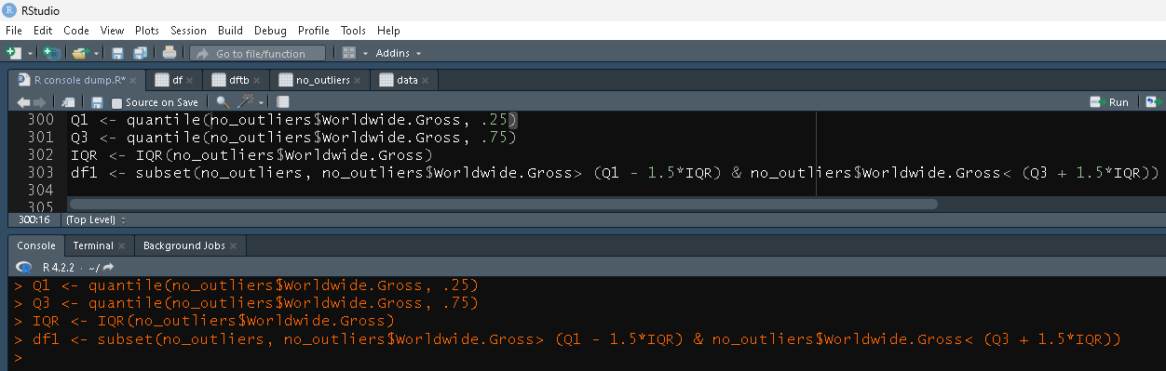

## Checking df1 data set (variable) for the current row and column count

dim(df1)

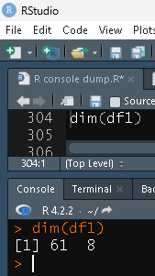

# 15. Summary Statistics/Univariate Analysis

summary(df1)

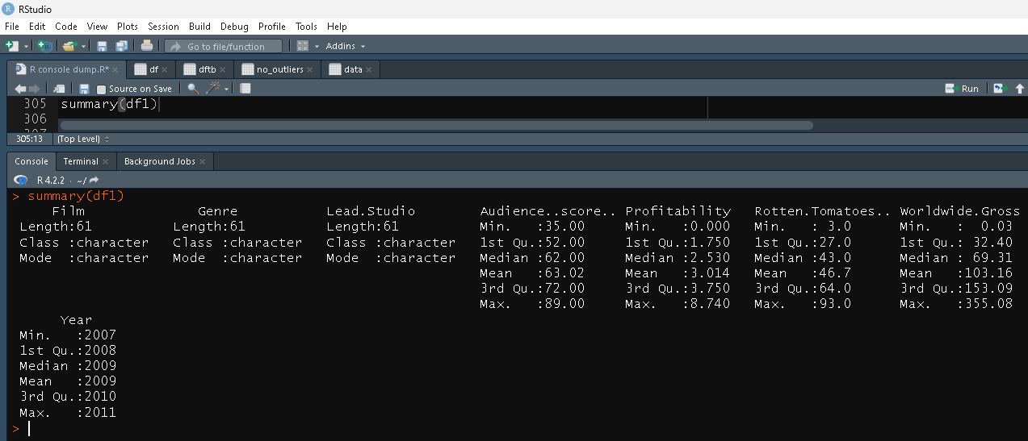

# 16. Bivariate analysis

## Scatterplot

ggplot(df1, aes(x=Lead.Studio, y=Rotten.Tomatoes..)) + geom_point()+ scale_y_continuous(labels = scales::comma)+coord_cartesian(ylim = c(0, 110))+theme(axis.text.x = element_text(angle = 90))

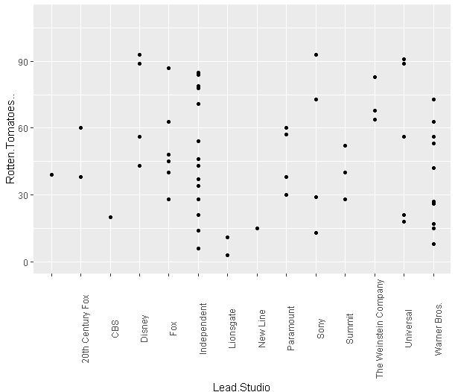

## Bar Chart

ggplot(df1, aes(x=Year)) + geom_bar()

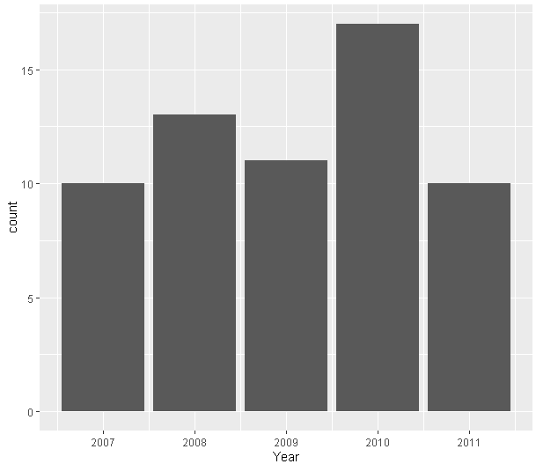

# 17. Exporting clean data

write.csv(df1, "clean_df.csv")

# 18.Power BI Dashboard

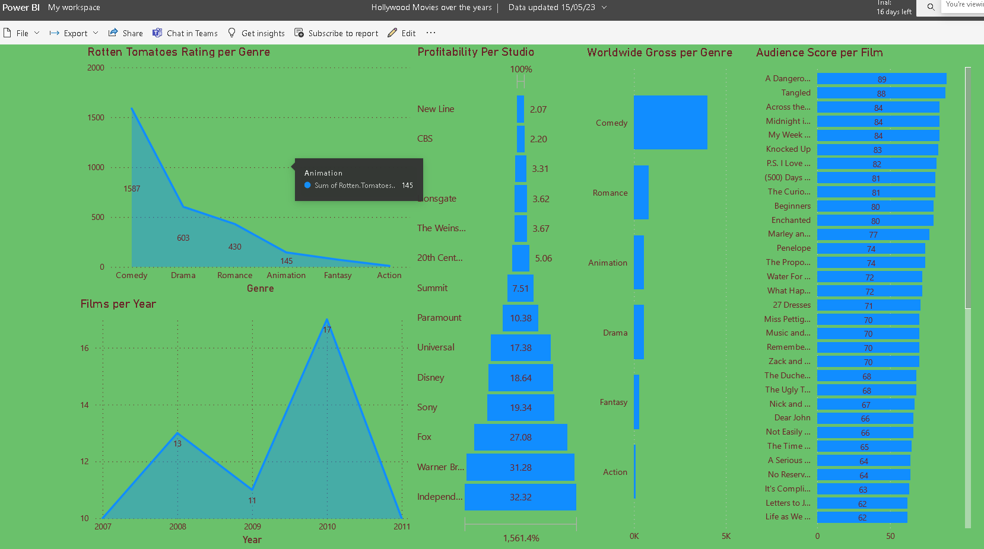

<https://app.powerbi.com/groups/me/reports/5c45af6f-3824-4a10-82e8-20ac69693138/ReportSection>